Revenue Rollup and Tiering Engine
Architecture: High-Level and Low-Level Design (no code)

1. HLD: Where Triggers Live and Why
Create three triggers, one per object, with no logic of their own. Each trigger only hands Trigger.new, Trigger.oldMap and the operation context to its handler.
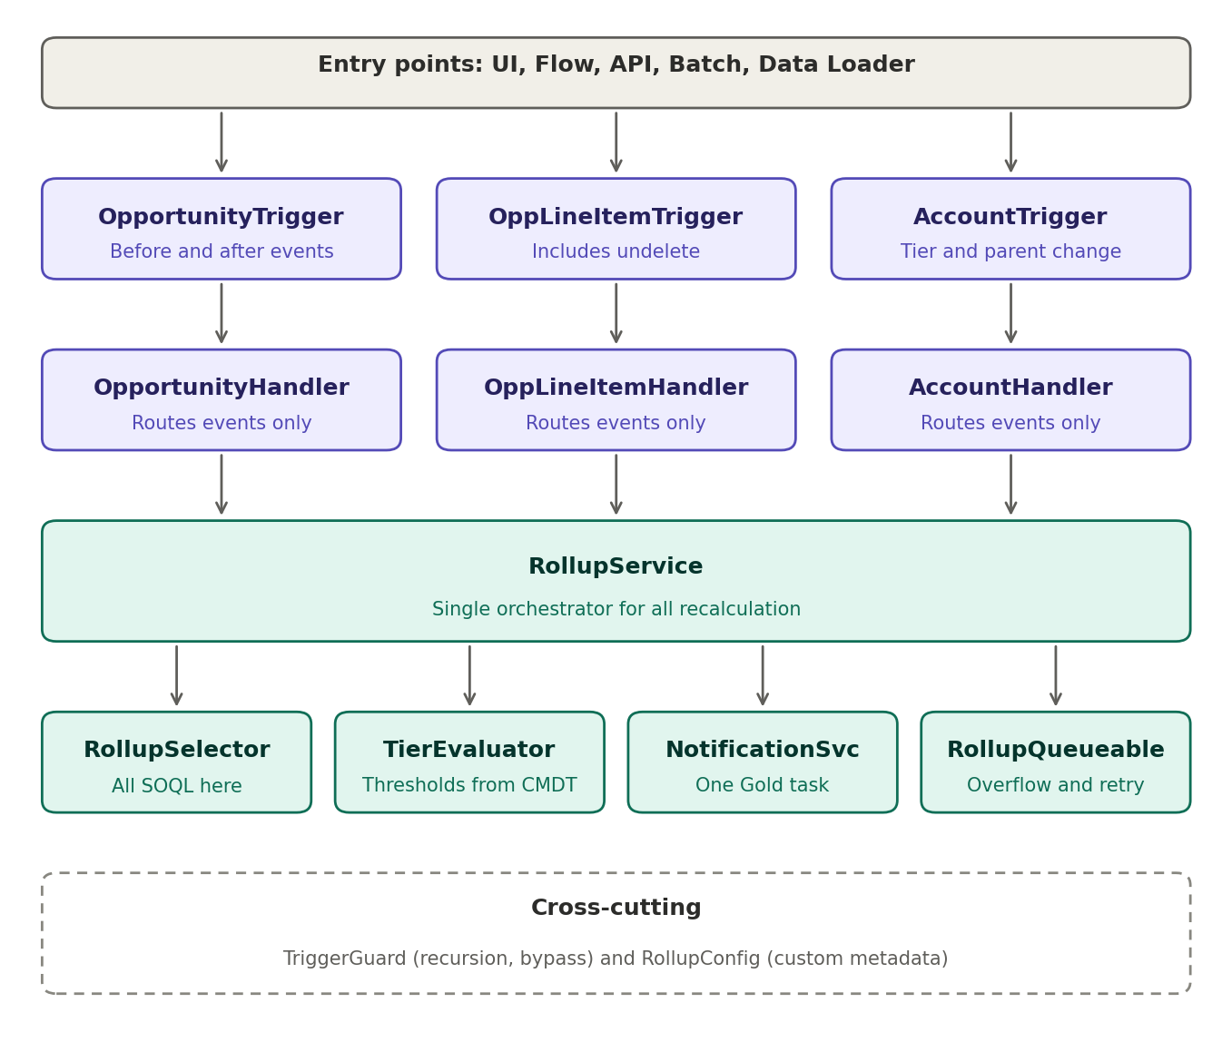
Trigger | Events | Why it is needed
OpportunityTrigger | before insert, update; after insert, update, delete, undelete | Before: block bad Closed Won. After: stage change, account reparenting, delete/undelete.
OppLineItemTrigger | after insert, update, delete, undelete | Rule 1, plus keeping Discount_Exposure__c current.
AccountTrigger | before update, after update | Before: derive tier and Last_Tier_Change__c in memory with no extra DML. After: Gold task and ParentId change detection (rule 4).

Two design decisions carry most of the weight:
- RollupService writes only Lifetime_Won_Revenue__c. The tier is derived in AccountTrigger before update, so tier logic runs the same way whether the revenue came from a trigger, a Queueable or a data fix.
- The recalculation recomputes from source (aggregate query) rather than applying deltas. That makes it idempotent, so re-entry from Flows, batch and API is harmless.

2. LLD: Class Responsibilities
Class | Responsibility | Key methods (names only)
*TriggerHandler (x3) | Filter in memory first, then delegate. No SOQL or DML. | beforeUpdate, afterUpdate, afterUndelete
RollupService | Orchestrates: collect dirty accounts, lock, recompute, write only changed values, choose sync or async. | recalculate(Set<Id>), collectDirtyAccounts, applyResults
RollupSelector | Every query: ancestor walk, subtree walk, aggregate won revenue, FOR UPDATE lock. | getAncestorChain, getSubtree, aggregateWonRevenue, lockAccounts
TierEvaluator | Pure function: revenue to tier, from custom metadata. | tierFor(Decimal), hasChanged
NotificationService | Builds the Gold Task, once per account per transaction. | notifyGold(List<Account>)
RollupQueueable | Carries only account Ids, calls the same RollupService, retries on lock errors with an attempt counter. | execute, retryOrFail
TriggerGuard | Bypass check (custom permission or hierarchy setting), depth counter, processed-state maps. | isBypassed, markProcessed, alreadyProcessed
RollupConfig | Reads tier thresholds and async threshold from custom metadata, cached per transaction. | getThresholds, getAsyncLimit

Keep the sync and async paths on the same RollupService.recalculate method, so the logic exists only once.

3. LLD: Core Recalculation Flow
- The handler filters in memory and returns immediately if nothing relevant changed. This is how rule 2 gets zero extra queries.
- The handler collects the dirty account Ids. For example, an Opportunity moving from A to B contributes both A and B.
- RollupService asks the selector to walk up the ancestors level by level: at most 5 queries for the whole batch, not per record.
- If the affected set or hierarchy size exceeds the threshold, enqueue RollupQueueable and stop. Otherwise continue.
- Lock the ancestor accounts with FOR UPDATE, ordered by Id to avoid deadlocks. Lock before aggregating: the second transaction waits, then reads the first one's committed data (rule 7).
- Run one aggregate query for won revenue per account across the affected hierarchy, then roll totals up the tree in memory.
- Compare against the current value and against the value this transaction already wrote. Update only accounts whose value actually changed. This processed-state map is what ends any loop.
- One bulk DML on the Accounts. AccountTrigger then derives the tier, updates Last_Tier_Change__c only on change, and calls NotificationService on a non-Gold to Gold move.

4. Which Rule Lands Where
Rule | Component
1 Line item changes | OppLineItemHandler into RollupService
2 Stage change, zero cost otherwise | Opportunity handler's in-memory filter
3 Opportunity reparenting | Opportunity handler compares oldMap and newMap AccountId, passes both accounts
4 Account reparenting | AccountHandler compares ParentId, passes old chain and new chain
5 Block bad data | OpportunityHandler before update, addError per record; line item handler also guards when the parent is already Closed Won
6 One Gold task | Tier-change detection in AccountHandler, plus a processed-Id set in TriggerGuard
7 Concurrency | RollupSelector.lockAccounts, with RollupQueueable retry on lock failure

5. Points That Are Easy to Miss
- The aggregate query scans rows toward the 50,000 query-row limit, so base the async threshold on hierarchy size, not only account count.
- Don't guard recalculation by Id alone. If a Flow changes data after the first recalculation, an Id-only guard would skip the second one and leave a stale total. Guard on value-changed instead.
- Opportunity delete and undelete also need handling, since deleting an Opportunity cascades to its line items.
- For the async path, optionally set a stale flag on affected accounts in the same transaction and clear it when the job finishes, so readers know a total is pending.

6. Test Classes
TestDataFactory, OpportunityHandlerTest, OppLineItemHandlerTest, AccountHandlerTest, RollupServiceTest (bulk, query-count assertion), TierEvaluatorTest (pure unit), RollupQueueableTest (retry and threshold).

